

CSE 499(Section-13)

Senior Design Project

**Online Notes Gallery**

|  |  |  |
| --- | --- | --- |
| **Name** | **Id** | **Phone** |
| Md. Sayadul Haque | 1421353042 | 01402401793 |
| Nasir Ahmad | 1612658042 | 01701788696 |

**Faculty Advisor-**

Dihan Md Nuruddin Hasan

Lecturer

ECE Department

North South University

Fall, 2020

# Acknowledgement

We would like to give special thanks to our honorable faculty Dihan M Nuruddin Hasan for his guidance, support and encouragement throughout the course. Without his guidance and encouragement, it was very hard for us to complete this project in this manner.

We would also like to thank our university mates who help us out online and offline at this time when going out of home and meeting is really a big deal for us.

Finally, We want to show my gratitude to my university which offers me such a course that offers us such opportunity and time to do a project in a professional manner.

# Abstract

Online Notes Gallery is a web-based notes sharing and management system which helps students and teachers to share their notes online effectively.It reduces the wasting of time in manually distributing notes to each individual. It greatly overcomes the lack of availability and converts the manual old paperwork to a fully automated and managed online system.

Online Notes Gallery allows its users to securely register and log in to their individual accounts and create, read, update, delete notes according to their needs. It provides notes to everyone in a very secure manner. Multiple users can work in this system at the same time under centralized supervision by the administrator. It is a very useful notes management system for Universities,Colleges, Schools and other Institutes to manage and share their notes in a secure, efficient and effective manner.

Table of Contents

**Acknowledgement** **2**

**Abstract** **3**

**Chapter 1** **6**

**Overview** **6**

Introduction 7

Project Description 7

Technical approach 8

Summary 8

**Chapter 2** **9**

**Existing Systems** **9**

Introduction 10

Existing Systems 10

Summary 10

**Chapter 3** **11**

**System Design** **11**

Introduction 12

System Description 12

Front-end System: 12

Backend part: 14

System Diagram 15

Summary 15

**Chapter 4** **16**

**Technical Description** **16**

Introduction 17

Technical Description 17

Tools: 17

Technologies: 17

Summary 18

**Chapter 5** **19**

**Design Implementation** **19**

Introduction 20

Front-end Design 20

Figma Design: 20

**Chapter 6** **31**

**Result and Analysis** **31**

Introduction: 32

Real website: 32

**Chapter 7** **40**

**Conclusion** **40**

Introduction: 41

Common Questions about the project: 41

Github Link of the Project: 43

# 

# 

# 

# 

# 

# **Chapter 1**

## Overview

### 

### **Introduction**

This is the time of technology. Technology is making our life easier day by day. Now we can avoid so many hectic problems and hassles due to technological advancement. Web development is one of the most important sectors of technological advancement through the Internet and electronic devices. Now-a-days we can chat or call each other through the internet from our mobile phones or computers without cost. How is it possible? Maybe because of a social media website for example Facebook, Twitter etc. We also have E-commerce websites like Daraz, Chaldal etc where we can order necessary things online from home and get delivery to home. This is how different kinds of websites are solving our different kinds of problems.

Designing these kinds of websites, developing the frontend and backend part of these kinds of websites, hosting and maintaining these kinds of websites, working for developing these kinds of websites and giving front-end and back-end security to these kinds of websites for maintaining them safely is called parts of Web-development. Web development is targeting different kinds of problems in our life that can be solved through websites.

Now-a-days in Bangladesh it is very common to use notes for Educational purposes. According to our education system, our school,college and university students have so many subjects to cover for a single exam. They have to collect so many notes for different subjects from different places, people and websites. Even though some people have all notes from a subject, they can’t share it with all who actually need it at different times and in different exams. We will try to use our web development skills to solve this problem using different types of web development technologies.

### **Project Description**

We all know how many problems as a student and teacher we have to suffer from organising notes for different subjects and letting others download them. During Covid time Google Classroom helps us a lot to organise them. But Not everyone and every organization can afford a paid Google cloud for them. And free google classroom users have a lot of limitations. Moreover, In the market there are so many note organizing platforms but some of them are not free and some of them have lagging issues with lots of ads.

What we feel is we need a secure, simple and lagging free platform only for organising our different kinds of notes in one place in such an order that anyone can download them from any part of the world at any time. If we say this in one line, we need a precise solution only for notes organizing that can be used for free.

### **Technical approach**

First,We want to use a web based solution for our students and teachers to organize all their notes subjectwise in one place and let others download them from anywhere in the world at any time.

Our second and future approach will be developing apps of this platform for android, ios etc.

### **Summary**

So now you know why we are implementing this project and what is the significance of it. And you also know that our first approach will be a web based solution. And our future approach will be developing apps for different platforms.

# 

# 

# 

# 

# **Chapter 2**

## Existing Systems

### 

### **Introduction**

We all have google classroom, microsoft onenote etc to use for organising our notes and sharing with others.But as we talked they are not completely free and and these platforms are not only for organizing notes and sharing with others which sometimes makes people annoyed who are actually not known with these technologies.So our web based solution will help them to use our website easily only for notes organizing and sharing purposes.

### **Existing Systems**

If we specifically talk about existing solutions for only organising notes and sharing with others, there is actually no renowned solution only focused on this problem.But Yes there are some renowned platforms with multi tasking where organizing notes and sharing them are available but these are very complicated to use for general people and they are not fully free and there are so many limitations for free users. Some of them are:

* Google Classroom
* Microsoft One Note

Our target is to design and implement a web based solution and develop apps for mobile platforms as a future approach to organize notes and share them with others only like these existing platforms. But our platform will only focus on this specific problem and we will provide every facility to users for free. Moreover, our platform will be very simple to use which will help general students to manage their notes easily on online platforms.

### Summary

So, now you know why we choose this platform to develop as you know what is the situation of existing platforms to solve this particular problem.

# 

# 

# **Chapter 3**

## System Design

### **Introduction**

Our target is to solve the problem using a website which will have a front-end and a back-end technology.

### **System Description**

#### **Front-end System:**

*Introductory Page:*

On this page we will have some images related to our websites, and a heading bar where we will have several options to click. They are:

* Login - When we click on the login button, we will go to the Login page directly.
* Sign-up-When we click on the SignUp button, we will go to the Login page directly.
* Upload Notes-When we click on the Upload Notes button, we will go to the Login page directly.
* About us-When we click on the About Us button, we will go to the About Us page directly.

*Signup page:*

Signup page will have the heading bar from the introductory page in common and will ask some information from the user to input in order to signup for creating an account in the system.

Asking informations are:

* Name- You have to provide your name correctly.
* Email- You have to provide a valid email address.
* Username- You have to provide a username for your account.
* Password- You have to provide a password for your account.
* Gender- You have to select your gender.
* Teacher or student?- you have to select any one options: Teacher or Student
* Field of subject- You have to select your subject from the list of subjects or have to type your subject.

After giving these informations correctly, users have to press the signup button to create an account into the system. If informations are provided correctly without no general error, it will show “Sign up successful” and if not correct, then it will show which information had been provided or “Sign Up unsuccessful”

*Login page:*

Login page will have that heading bar from introductory page in

Common and will ask some information from user to login to the

System. Asking informations are:

* Username- You have to type your account username.
* Password-You have to enter your account password.

After giving these informations correctly, users have to press the login button to login into the page. If informations are correct, it will show “login successful” and if not correct, then it will show which information is wrong or “login unsuccessful”

*Upload Notes Page*

This page will have three options:

* Dashboard- Dashboard will have a list of notes that have been uploaded on the page from different users.
* My notes-

This will show two options to select-

* + - View All notes- Here you can find all your notes that have been uploaded by you.
    - Upload Note- Here you can upload your notes by uploading a file and by giving a title for that file.
* My Account

This will show two options to select-

* + - View Profile- You can see your profile information here.
    - Edit profile-You can edit your profile information here and can add profile pic for your profile.

#### 

#### **Backend part:**

*Internet Connection:*

Full website will be run by the support of the internet. Without internet connection it is not possible to go to our website by dialing a specific address on the browser.

*Hosting address:*

For loading our website on a particular address, we have to buy that address domain from a hosting provider. All files related to website and all data of of websites will be stored and maintained by that hosting company on that particular address

### **System Diagram**

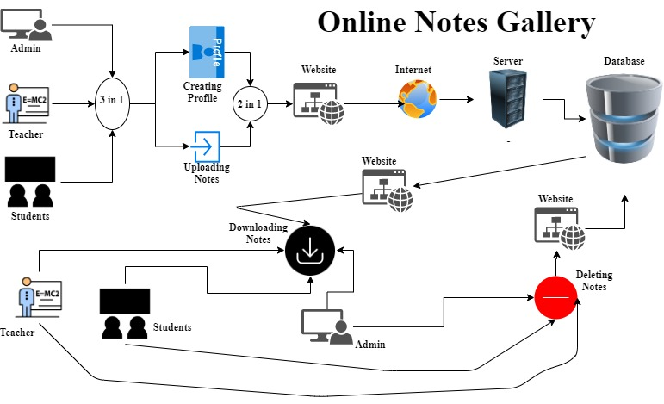

### **Summary**

Now you know how our system will work as a website on the front-end and on the back-end part. Hope this will help you to understand the main theme of the working method of our website.

### 

# **Chapter 4**

## Technical Description

### 

### 

### **Introduction**

On this part we will talk about tools and technology which will be used to develop our websites. After this part, you will know actually about every tool and technology that will be used for developing our websites.

### **Technical Description**

#### **Tools:**

* *XAMPP:* XAMPP is an abbreviation for cross-platform, Apache, MySQL, PHP and Perl, and it allows you to build WordPress sites offline, on a local web server on your computer. This simple and lightweight solution works on Windows, Linux, and Mac – hence the “cross-platform” part.
* *ATOM:* Atom is an open-source text editor for multiple platforms, which supports packages developed in Node.js and has support for Git version control. Most of the packages are freely available and built by open-source communities.

#### **Technologies:**

* *PHP*: - PHP (recursive acronym for PHP: Hypertext Preprocessor) is a widely-used open source general-purpose scripting language that is especially suited for web development and can be embedded into HTML.
* *SQL: -* SQL is a structured query language used for querying databases.
* *HTML: -* It is used for giving eye-catching looks to the website. And also providing easy to use GUI.
* *CSS: -* CSS is a cascading style sheet which is used to give a designer look to HTML using the external file.
* *Java script: -* Javascript is used for client-side scripting which can help in using validation on the website and many more other functions.

### **Summary**

Now you know tools and technologies for developing our website and you also know the importance of every tool and technology to develop an ideal website.

# 

# 

# 

# 

# **Chapter 5**

## Design Implementation

### **Introduction**

In this part, we will describe the whole design implementation for our website through different ways. In-sha-Allah You will get everything clear about our work after the design Implementation part.

### **Front-end Design**

#### Figma Design:

Home page

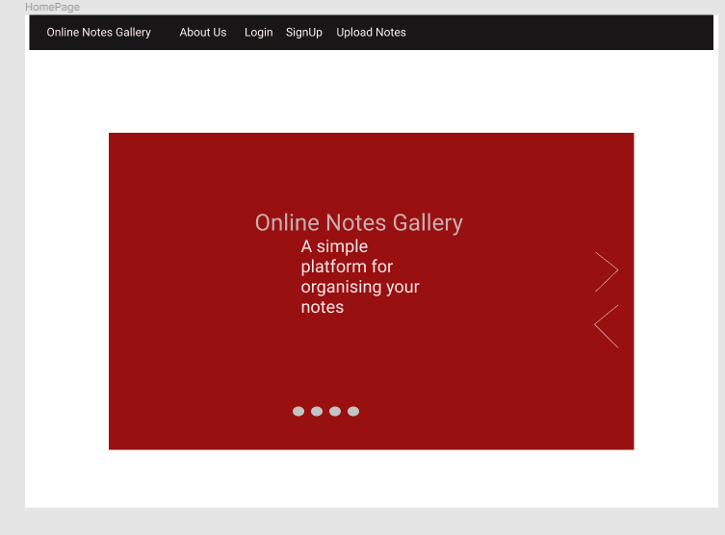

Sign Up page

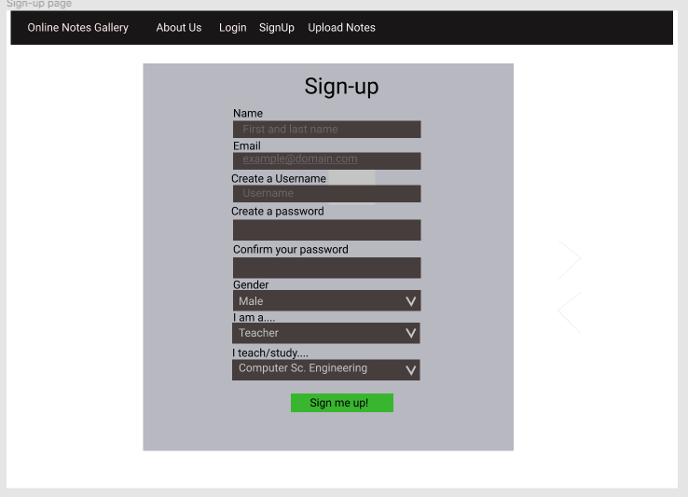

## 

Login Page

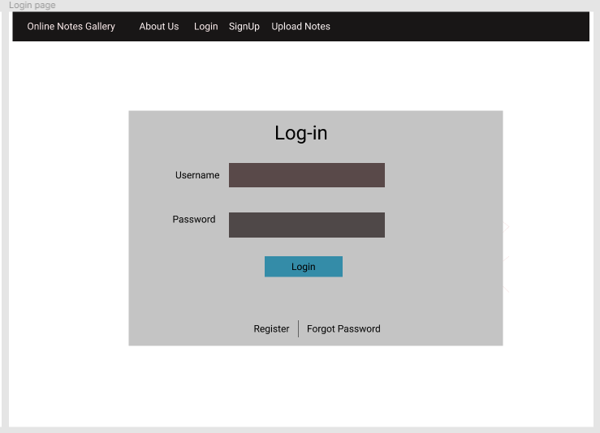

Dashboard page(for admin)

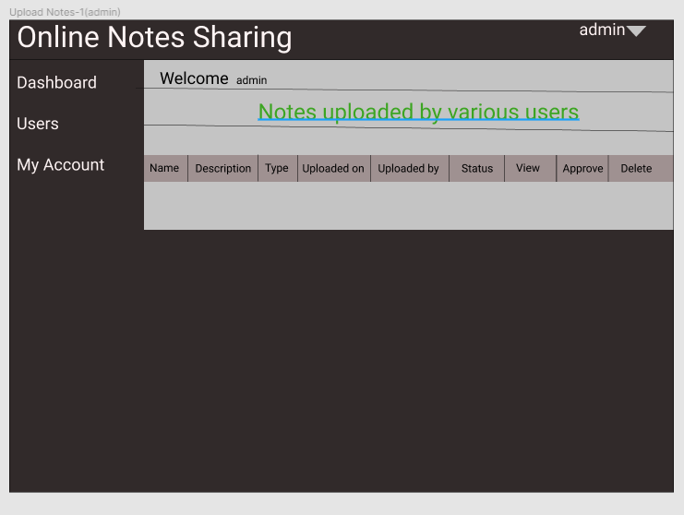

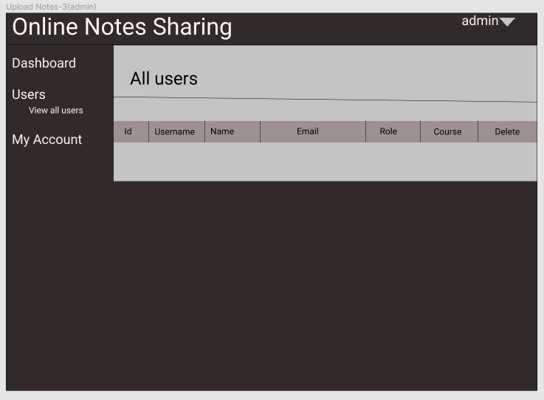

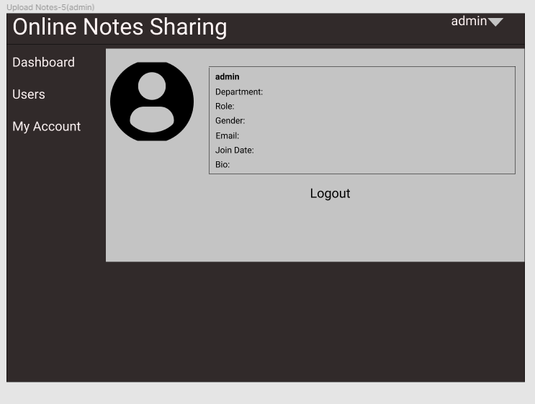

Dashboard page(for user)

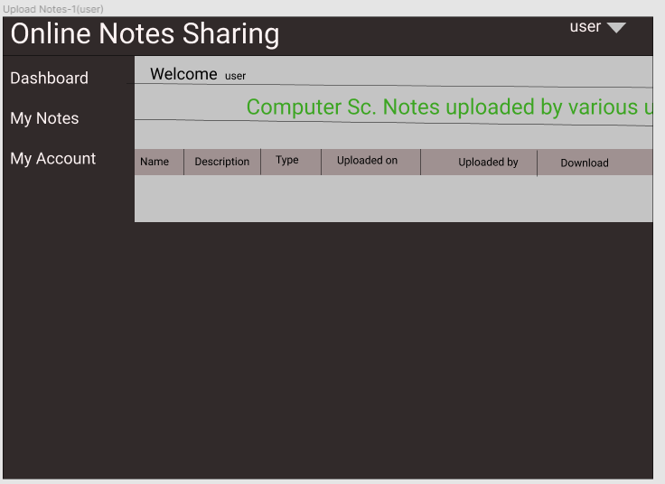

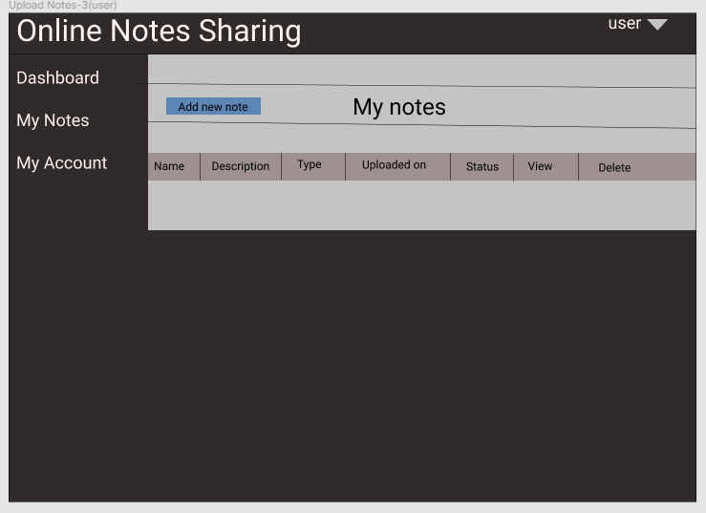

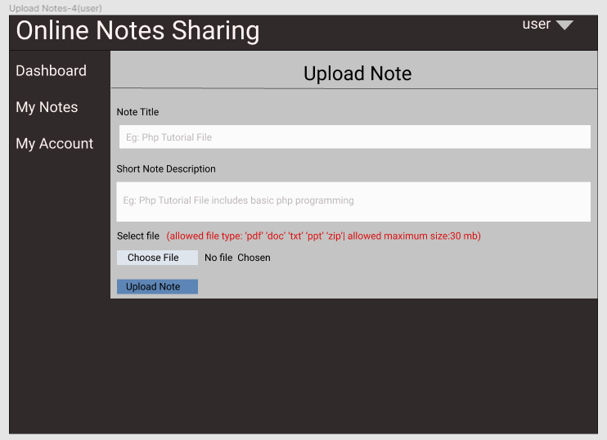

View Profile page



Edit Profile page

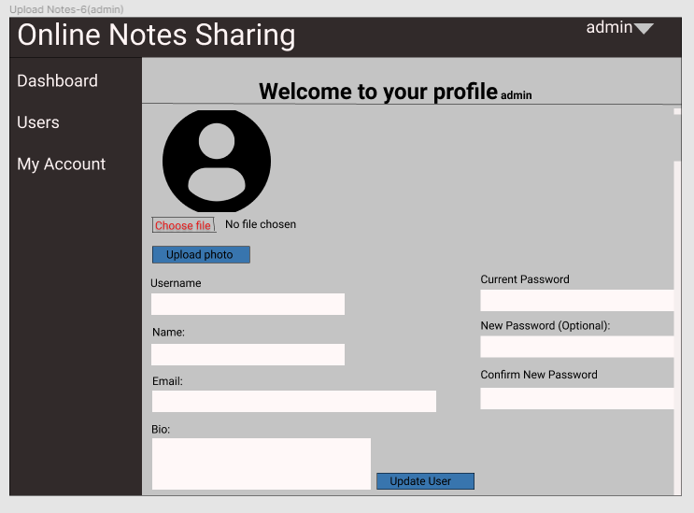

# 

# 

# 

# **Chapter 6**

## Result and Analysis

### **Introduction:**

In this part, we will show some screenshots of our real websites.

### **Real website:**

Homepage

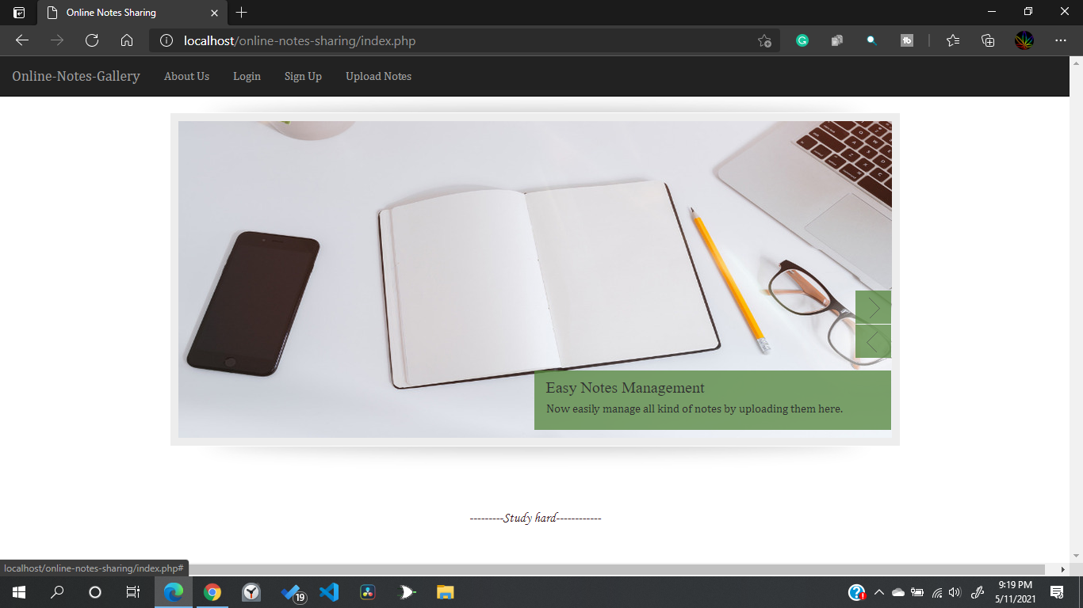

Login Page

# 

# 

# 

# 

Signup Page

# 

Panel(For Admin)

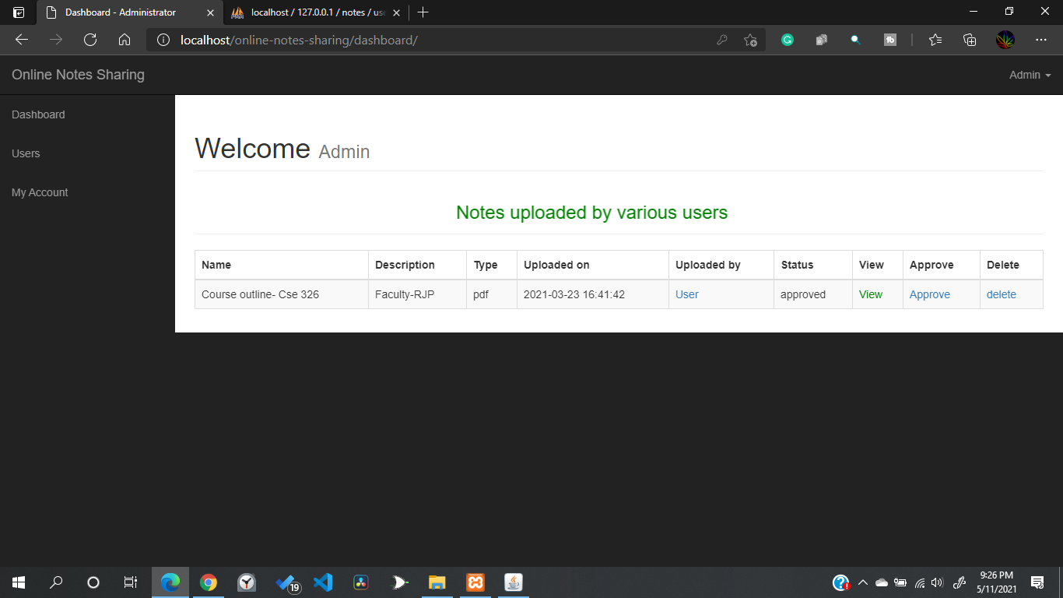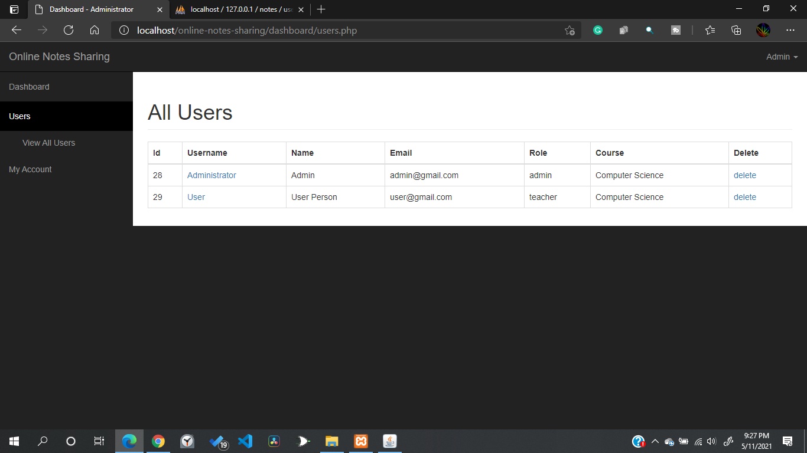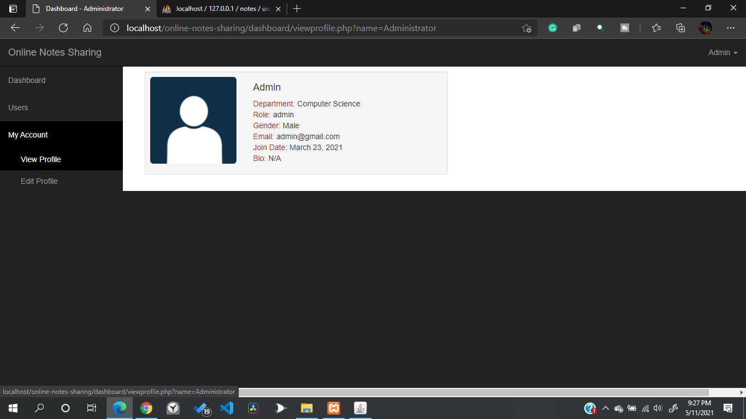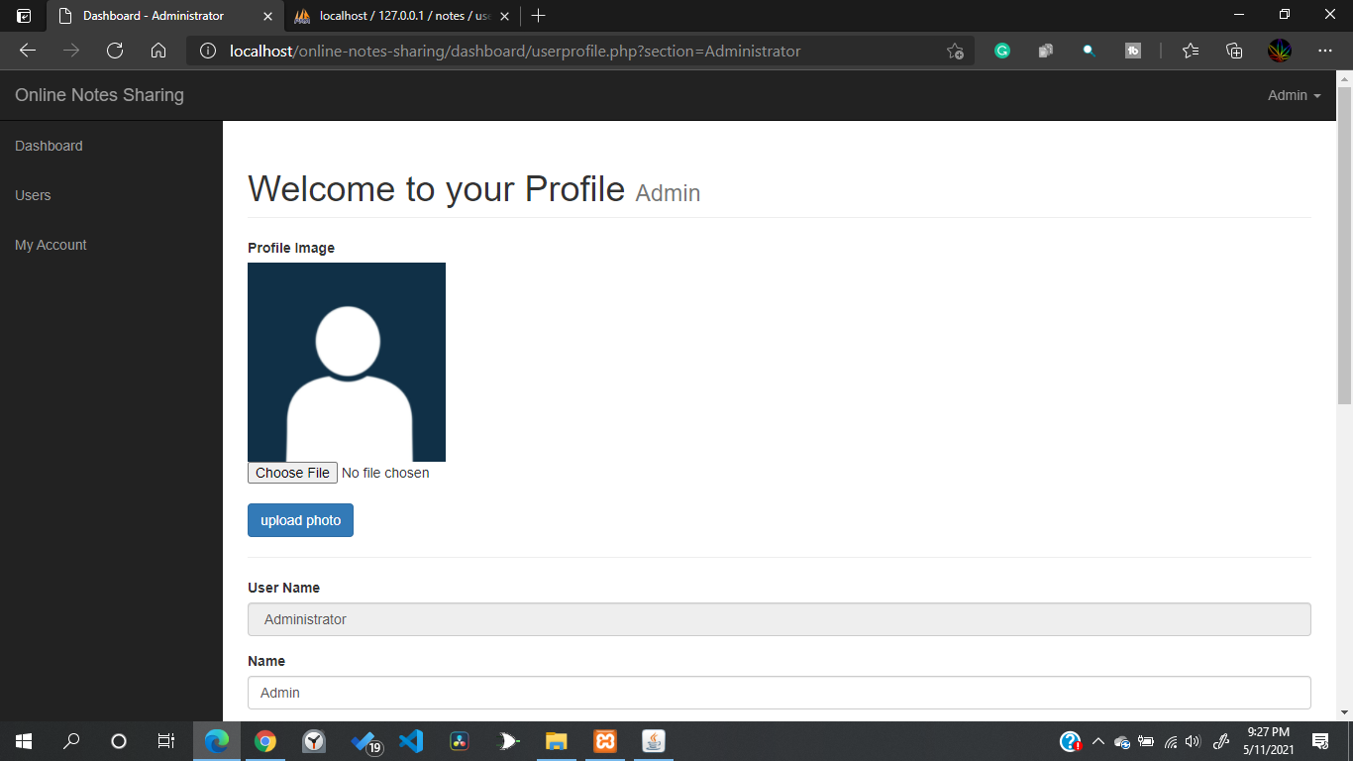

Panel(For user)

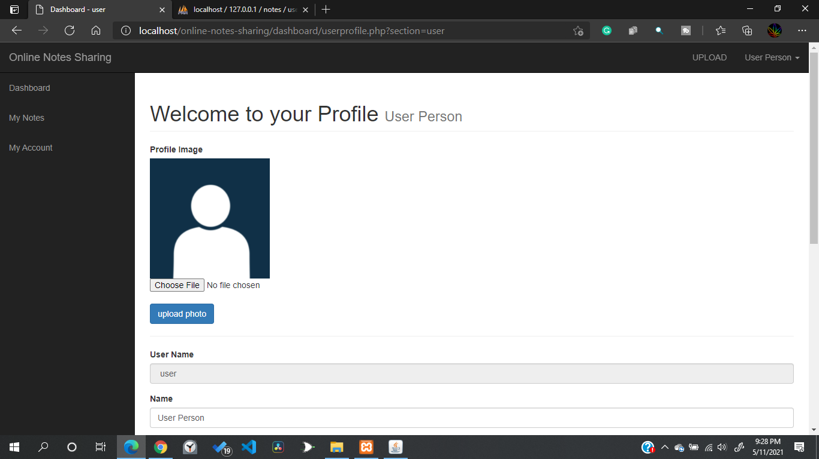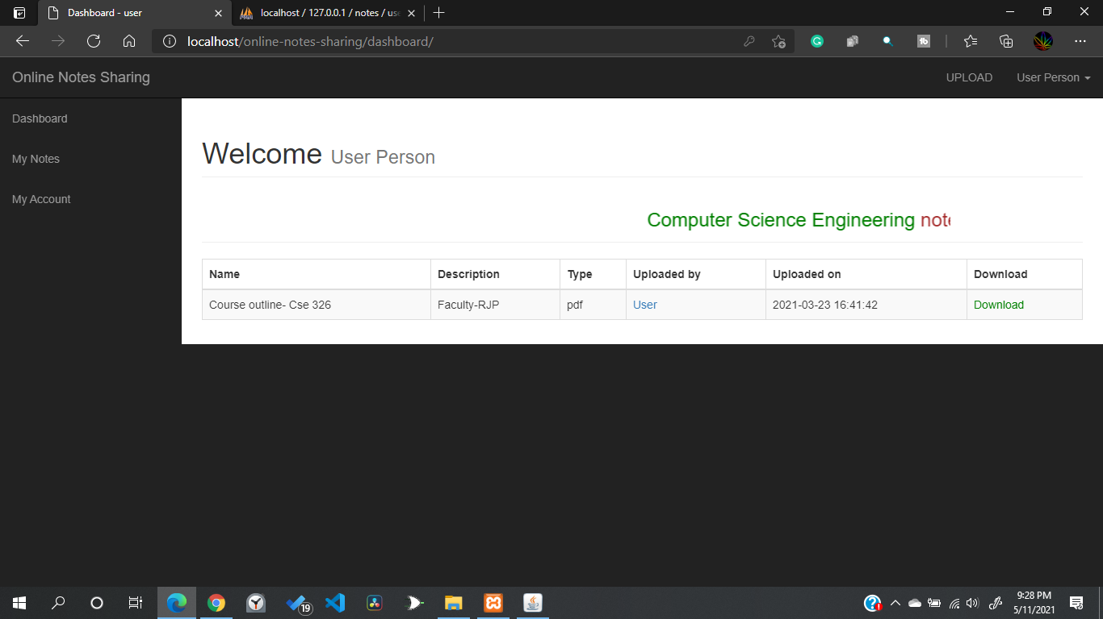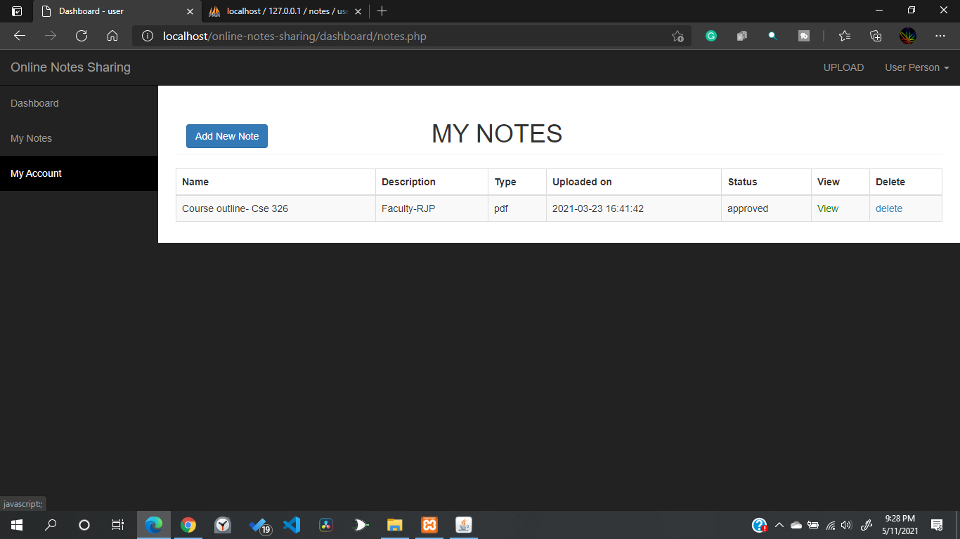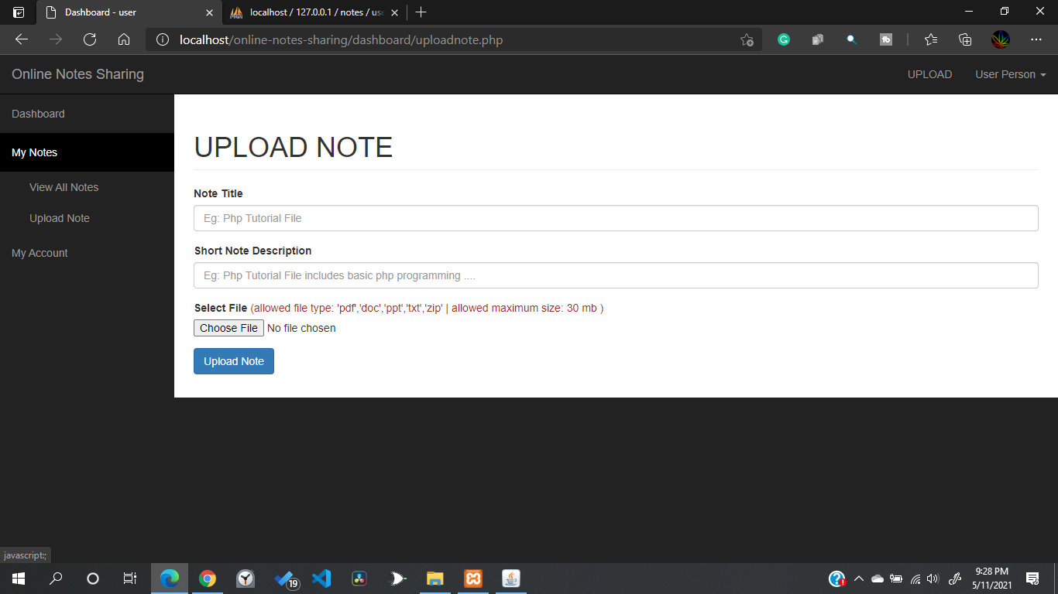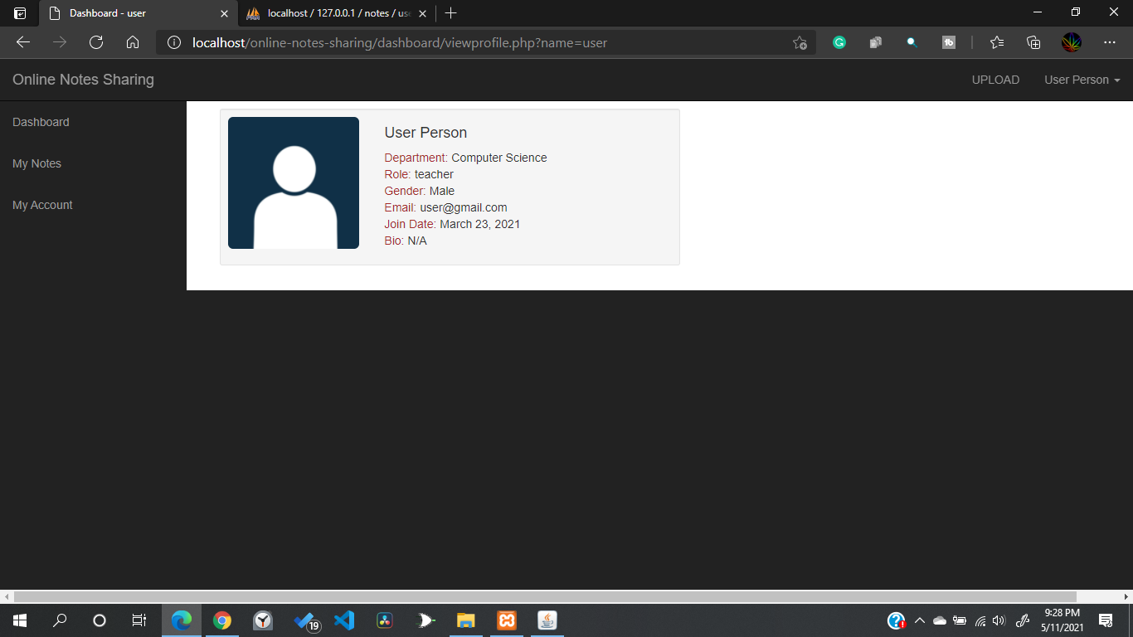

# 

# **Chapter 7**

## Conclusion

### **Introduction:**

In this part, we will have answers of some common questions about the project. We will also provide the github link of our project.

### **Common Questions about the project:**

**(1) What is new in your idea?**

Answer- Our idea is more focused for this particular problem because there is no other website dedicated to online notes management. So we are solving a particular problem which is very common but it did not get that much attention before.

**(2) How is it relevant to the users in Bangladesh?**

Answer- There are so many schools, colleges and universities in Bangladesh where teachers and students are still facing so many problems for manual note work and sharing notes with others. Our focus is those schools, colleges and universities. As a future implementation of this project we also plan to release a premium version of this website which will be dedicated to a particular school, college or university with premium hosting address.

**(3) What are the state of the art( similar solutions) ?**

Answer- If we specifically talk about existing solutions for only organising notes and sharing with others, there is actually no renowned solution only focused on this problem.But Yes there are some renowned platforms with multi tasking where organizing notes and sharing them are available but these are very complicated to use for general people and they are not fully free and there are so many limitations for free users. Some of them are:

● Google Classroom

● Microsoft One Note

Our target is to design and implement a web based solution and develop apps for mobile platforms as a future approach to organize notes and share them with others only like these existing platforms. But our platform will only focus on this specific problem and we will provide every facility to users for free. Moreover, our platform will be very simple to use which will help general students to manage their notes easily on online platforms.

**(4) How to commercialize your idea in Bangladesh ?**

Answer- As we said, As a future implementation of this project we have a plan to release a premium version of this website which will be dedicated to a particular school, college or university with a premium hosting address.It can be commercialized in this way. If we can add some extra creative features for the premium version, we can design it for different institutions regarding their needs. Web and app development is a huge market and commercializing any needy thing here is actually easy with the right advertising and marketing policy.

**(5) What are the obstacles you are currently facing ?**

Answer- Obviously we are facing some:

1. Time shortage because of our other educational responsibilities. For web development you actually need a good amount of time.

2. Security concerns are another problem. After developing every website, the first thing we need to do is assure the security of that website. So if we have a website security specialist in our time, we could have better options of organising our codes for different pages using security gates.

3. Technical face to face meetings are one of the most important problems right now. There are actually very few options to meet with team members which is actually giving us some kind of problem.

**(6) How to improve your current solution ?**

Answer- As we said before,we have a plan to release a premium version of this website which will be dedicated to a particular school, college or university with a premium hosting address. If we can add some extra creative features for the premium version, we can design it for different institutions regarding their needs. Web and app development is a huge market and commercializing any needy thing here is actually easy with the right advertising and marketing policy. In our mind this can be a future improvement.

**(7) What are the socio economic and legal challenges you may face eventually in Bangladesh for practical implementation** ?

Answer- Let’s see what are challenges regarding our country-

(1) In our country people love free things. They don’t want to pay for premium things. So most of the developers don’t feel interested in implementing premium things practically.

(2) Most of the schools, colleges and universities are still not ready for digital solutions for solving their daily problems.

(3) We don’t value entrepreneurs.

### **Github Link of the Project:**

[Saidul00005/Online-Notes-Gallery: A website where you can upload and download notes with many more opportunities. (github.com)](https://github.com/Saidul00005/Online-Notes-Gallery)

-------------------------------------------------------